## United States Soybean Quality

Annual Report

2023

14 November 2023

Seth L. Naeve and Jesse Christenson

2023 Quality Report 1

References 14

Figure 1: US Soybean Planting and Harvest Progress 15

Figure 2: US Soybean, Corn, Wheat Harvested Area 16

Figure 3: US Protein and Oil State/Regional Summary……………………. 17

Table 1: Production Data for the United States, 2023 Crop 18

Table 2: Quality Survey, Protein & Oil Data 19

Table 3: Quality Survey, Seed Data 20

Table 4: Quality Survey, Amino Acid Data 21

Table 5: Historical Summary of Yield & Quality Data, US Soybeans 22

Contact Information 23

## Summary

The American Soybean Association, United Soybean Board, and US Soybean Export Council have supported a survey of the quality of the US soybean crop since 1986. This survey is intended to provide new crop quality data to aid international customers with their purchasing decisions.

## 2023 Area, Yields, and Total Production

Early season soybean planting started rapidly in the U.S., led by a very early start in Illinois where 40% of the crop was planted by May 1. Indiana, Ohio, and Missouri also got off to a very good start. Early planting bodes well for good yields in these Corn Belt states. Initial planting in Iowa was on pace with historical trends but the start of planting in Minnesota and North Dakota was delayed. Unusually cold temperatures during mid-April delayed the end of winter and kept farmers in the Northwestern parts of the Corn Belt out of their fields until early May.

Early May plantings are near ideal for many states in the Corn Belt, and Iowa farmers took advantage of good weather beginning in May to plant in earnest. While only about 15% of Iowa soybeans were planted on May 1, by May 14 that number had increased to 69%. Planting in Minnesota began in early May and only reached 30% by May 14. North Dakota was most affected by the lingering cold temperatures of winter into the late spring and only reached 2% planted by this same date. Heavy rains in the Eastern Corn Belt in early May inhibited planting in Ohio, resulting in a pause in planting during the first week of May. However, planting then resumed at a record pace and 63% had been planted by May 21. Overall, U.S. soybean planting progressed at 7-10 days ahead of the average planting pace throughout the spring.

As defined by the USDA, average U.S. soybean crop conditions began June at a lower level than recent years due to drought conditions in the Western Corn Belt and crop conditions were maintained at relatively poor levels throughout the summer (USDA NASS). These poor crop conditions primarily resulted from a broad and chronic drought throughout much of soybean producing areas of the U.S. The most severe drought was found in the Western Corn Belt states. The soybean crop tended to improve after June in Missouri, Illinois, Indiana, and Ohio; whereas conditions either maintained themselves at low levels or decayed through the summer in Iowa, Minnesota, the Dakotas, and Nebraska.

More detail is provided in the weather section; however, broadly, significant to extreme drought condition persisted all summer throughout the center and Western ranges of the Corn Belt. The states of Iowa, Minnesota, Wisconsin, Nebraska, and Kansas were under severe drought for nearly the entire growing season. Highly localized rains were able to help some farmers through the summer months, while other farmers saw very low yields. Common in the Midwest, farms with heavy and deep soil profiles with excellent water holding capacity were able to utilize excessive spring rains to maintain yields.

Warm summer temperatures and early planting allowed for a somewhat early soybean harvest in some states. With few significant weather delays, the U.S. soybean crop was harvested at a normal pace.

Area planted to soybean was down in 2023 and harvested acres are expected to be reduced by around 4% relative to the 2022 crop. October 12 yield estimates from the USDA are identical to those realized in 2022. This leaves the U.S with a crop of 4.1 billion bushels or 112 MMT. Some private estimates are suggesting a slightly larger U.S. crop, so there is potential for it to grow. The top three soybean producing states of Iowa, Illinois, and Minnesota are each expected to have both fewer acres of soybeans and lower yields. These three states produce nearly 40% of the U.S. crop and therefore drive total production and average composition values. Combined area and yield estimates for 2023 results in a reduction in production of 2.2MMT from these three states alone when compared with 2022.

Other than North Dakota, the remaining six major soybean production states are expected to produce higher yields in 2023, than 2022. South Dakota increased both area devoted to soybean and expected soybean yields resulting in an increase in production of around 0.7MMT. Among smaller states, the neighboring state of Wisconsin also contributed to lower overall production in 2023. Yields in Wisconsin are expected to be reduced by 13% and area by 17% compared with 2022 levels leading to a reduction in total production of around 0.7MMT to exactly cancel South Dakota’s increased production.

## Quality of the 2023 US Soybean Crop

Sample kits were mailed to 3,886 producers that were selected based on total land devoted to soybean production, so that response distribution would closely match that of soybean production at a fine geographical resolution. By 2 November 2023, 1,169 samples were received. This report will serve as the initial preview of the 2023 U.S. soybean crop. The final report for the 2023 US soybean crop including late harvested soybean samples will be available in the first week of 2024.

Samples were analyzed for protein, oil, and amino acid concentration by near-infrared spectroscopy (NIRS) using a PerkinElmer DA7250 diode array instrument (PerkinElmer Inc., Waltham, MA, USA) equipped with calibrations developed in collaboration with PerkinElmer. A subset of samples was sent to two commercial laboratories for assessment by AOCS-approved analytical chemical methods in order to validate NIR quality constituent predictions. Regional and national average quality values were determined by computing weighted averages using state and regional soybean production estimates, so that average values best represent the crop as a whole.

## Protein and Oil

The 2023 US crop shows a decrease in protein of 0.2 points to 33.9 % and a slight increase in oil of 0.1 point to 19.6% (Table 2) when compared with 2022. For context, the 2022 US soybean crop had a relatively low protein level, of 33.9% that was 0.3 points below the previous ten-year average value. The average oil value in 2022 of 19.5% was slightly above the average for recent years (Table 5).

Compared with the prior ten-year average, 2023 protein was 0.5 points lower, and oil was 0.3 points higher. Despite an intense drought in the primary soybean producing states of the U.S. Corn Belt, average soybean protein and oil levels were similar to both last year and the historical averages.

While average values provide some insight to the overall crop no one produces, trades, or utilizes an average soybean. The drought certainly played a large role in affecting crop yields and seed quality harvested from those crops at a regional, state, county, and farm level. In fact, summer rainfall events are very spotty at the local level. This only becomes important under drought conditions where localized and timely rainfall events can make the difference between a crop failure and a very high yielding one. Soybean yields in 2023 varied at an extremely fine geographical level, and soybean seed quality did the same.

At the regional scale, the 2023 crop continued the trend of a geographical flattening of regional protein and oil levels. The Eastern Corn Belt (ECB) had lower protein levels than the historically protein challenged Western Corn Belt (WCB), but these regions were only about one half point lower than the traditionally higher protein regions of the Midsouth (MDS), Southeast (SE) and East Coast (EC). Due to later harvests and therefore small sample numbers in the Southern regions, crop descriptions will focus primarily on the three primary regions in the center and Northern production areas.

Regional changes in protein level were modest. The WCB was 0.1 point lower in protein than 2022, and the ECB and MDS were 0.3 and 0.2 points lower, respectively. Within region variation in seed composition continued in 2023. Nebraska and Iowa had protein levels that were 0.6 and 0.5 points higher in 2023, while South Dakota and Minnesota had protein levels that were 0.5 and 0.4 points lower in 2023. It must be noted that South Dakota and Minnesota had record high protein in 2022, while Iowa had very low proteins in 2022. It is likely that the widespread and chronic nature of the drought in 2023 produced a leveling effect on seed quality.

In the ECB, the neighboring states of Illinois, Indiana, and Michigan saw decreases in protein of 0.4, 0.4, and 0.8 points respectively. Wisconsin saw an increase of 0.3 points compared with 2022’s very low proteins (Table 2).

As was noted previously, planting date can affect soybean composition. Early planting tends to favor increased yields over protein concentration in the final seed. Mourtzinis et al. (2017) and Helms et al. (1998) found seed protein to increase with delayed planting, while oil concentration decreased at the same rate. While early planting in Illinois may have helped increase yields and lead to lower protein levels, early planting in Iowa did not have the same effect. The more significant drought in Iowa likely overrode any yield and quality effects. Reduced yields, themselves, in Iowa may have led to increased protein levels there.

The tradeoffs between protein and oil and seed yield make estimating soybean yields and composition quite difficult. Presence of drought has a large effect on yield and composition, but severity, timing, and duration of drought further complicates the impacts. Slight reductions in yield due to stress often result in increased protein and or oil; however, severe drought tends to reduce yield significantly, and seed quality with it. Iowa saw both protein and oil levels increase relative to 2022 levels. On the other hand, Kansas, Nebraska, and South Dakota all had lower protein levels, and only Nebraska showed some compensation with increased oil content.

Michigan was another unique state, in that both protein and oil decreased relative to 2022. There, protein declined by 0.8 points, while oil dipped by 0.2. Regional averages for oil content varied little from 2023. The MDS had the same oil content as 2022, while the WCB increased by 0.1 and the WCB by 0.2 points. Southern regions tended to have higher oil content than their Northern neighbors. State-to-state variability was not quite as dramatic as previous years, which was likely tied to late season drought stress.

Of significant practical importance is harvest moisture. While protein and oil values are provided here on a 13% basis for standardization, soybean processors effectively utilize soybeans on an as-is basis. The 2023 crop was not quite as dry as 2022, yet soybean samples averaged 11.5% with 66% of samples arrived at less than 12% moisture. Soybean moisture may not affect soybean meal protein levels, but drier soybeans increase meal and oil yields in proportion to moisture content. All purchasers will find as-is protein and oil levels to be higher in 2023 crop soybeans than usual.

## Seed WEIGHT, Test weight, FOREIGN MATERIAL, and SOYBEANS OF OTHER COLORS

Seed weight in soybean is important for some food uses but tends to have little impact on the value of conventionally processed soybeans. However, seed weight does help provide insight into the production environment and potential yield-limiting phases in crop growth. Seed weight is an indicator of the relative differences in growing environment in midsummer vs. late summer. Pre-harvest yield estimates are primarily based on counts of seeds per unit of area. These estimates are not able to include seed weight as this is determined late in the soybean’s growth cycle. Improved yield estimates would be possible with better estimates of seed size.

Average seed weight of the 2023 crop decreased by one full gram per 100 seeds. This is a 6% decrease from the 2022 average of 16.8 g per 100 seeds. With yields estimated to be similar to 2022, this indicates that the 2023 crop had the potential to be much larger; however, late season stresses, primarily from drought, limited this crop’s size. While nearly every state and region saw a reduction in seed size compared with 2022, The Western and Eastern Corn Belt regions were primarily responsible for this change (Table 3). Iowa (15.8 g per 100 seeds) and Kansas (13.1 g per 100 seeds) saw reductions of around 2 g compared with 2022. Likewise, neighboring states of Nebraska, Illinois, Indiana, Wisconsin, and Iowa all saw seed size reduced by one or more g per 100 seed when compared with 2022. Despite being smaller than last year, the far northern states of North Dakota, Minnesota, Wisconsin, and Michigan produced near normal seed size. These states may exceed earlier yield estimates that were based on seed number alone.

Test weight (TW) is a measure of density of grains. It is an important quality factor in cereal grains, but it affects soybean quality little and is not a good indicator of value to the processor. We report it here as it is often measured and reported with little context. Average US TW increased significantly from previous years when 56-57 pounds per bushel has become standard. Average TW increased from 57.2 in 2022 to 60.7 in 2023. As with seed size, TW changed most from 2022 in the WCB and ECB. Here TWs increased by nearly 3 pounds per bushel. Missouri produced a whopping 65.7-pound TW (Table 3). The geographically scattered states of Kansas, North and South Dakota, Wisconsin, Michigan, and Indiana all produced seed that had average TW of greater than the standard 60 pounds per bushel.

Foreign material (FM) in soybeans sampled at the farm level continues to be very low in the US. Average FM level in US soy was 0.2% in 2023 (Table 3), 0.1 point lower than in 2022.

Of 1,169 samples, only 15 had FM levels of greater than 2% and 39 had FM levels between 1-2%. Contamination with FM was less than 1% in 96% of samples (1,118 of 1,169).

## Sucrose

Soybean meal provides not only protein, and therefore amino acids, for animal feed, but it also adds to a ration’s energy (Stein et al., 2008). Sucrose in soybean and soybean meal contributes to total Metabolizable Energy (ME) in livestock feed. Although soybean meal is an important contributor to a ration’s total ME, nutritionists often use ‘book values’ for energy from soybean meal that does not differ across soybean origins. Our work highlights the potential variation in ME in soybean meal based on varying sucrose levels in soybeans. This variation tends to have a strong geographical basis to it. We have found that soybeans from the US have higher sucrose than soybeans from Brazil (Naeve, unpublished data), which is desirable since sucrose is positive for ME. In studies of soybean meal quality by origin, the apparent ME in US soybean meal was significantly higher than that in meal from Argentina and Brazil, and the higher sugar level in US soybean meal is likely a primary driver of differences in metabolizable energy (Ravindran et al., 2014).

Average US sucrose levels, at 5.4% in 2023 (Table 3), were significantly higher than those in 2022 (4.5%). Similar to large-scale differences between tropical and subtropical environments found in Brazil versus the U.S., we have found that soybeans produced in cooler regions of the U.S. also have lower protein without offsetting increases in oil, but higher sucrose levels. This trend was noted again in 2023. Far North states of North Dakota, Michigan, and New York had the greatest sucrose concentrations. Sucrose certainly shows some trade-off with protein, expressing higher concentrations where protein is lower. Sucrose followed the same flattening of the normal West to East gradient in protein noted this year; whereby sucrose was not significantly higher in the West than in the East.

## Amino Acids

Amino acids are the “building block” organic compounds linked in various combinations to form unique proteins. Optimal animal performance occurs when the feed protein contains an ideal amount and proportion of all essential amino acids (those amino acids which cannot be produced by animals).

In whole soybeans, lower crude protein translates to a higher relative proportion of the five most critical essential amino acids (lysine, cysteine, methionine, threonine, and tryptophan), indicating that meal made from those soybeans will likely be of higher feed quality for a given feed ration than meal made from higher crude protein soybeans (Thakur and Hurburgh, 2007; Medic et al., 2014; Naeve, unpublished data). We have even detected this relationship in the thousands of samples from highly variable US regions, varieties, and management tactics.

The relative abundance of lysine (expressed as a percent of the 18 primary amino acids) within the soybean protein fraction decreased only slightly from 6.9% in 2022 to 6.8% in 2023 (Table 4). Both WCB and ECB regions decreased by 0.1 point from year to year. There was much less variation in the relative abundance of Lys in 2023. All states averaged 6.8%. Similarly, the sum of the five essential amino acids (5 EAAs, expressed as a percent of the 18 primary amino acids) decreased from 14.9% in 2022 to 14.8% in 2023. As with Lysine, this is a simple reversal of the change from 2021 to 2022. There was relatively little variation between states or regions for this measure of protein quality. More northern states tended to have slightly higher levels in years prior to 2022. The flattening of geographical variation in amino acids follows the same trend noted with sucrose, protein, and oil over the past two years. Certainly, the large scale and chronic drought experienced in the past few years has led to an increase in the homogeneity of soybean composition in recent years – at least at the state and region level.

CORRELATIONS

Understanding how soybean compositional factors are related to one another can help us understand not only the trade-offs between attributes, but it can also lead to a better understanding of the fundamental biology behind these factors. The relatedness of two factors can be measured by the Pearson correlation coefficient expressed as a number between +1 and -1, where 1 is a perfect positive linear correlation, 0 is no linear correlation, and −1 is a perfect negative linear correlation. Correlations do not demonstrate causation. Correlations between factors can be found in the correlation matrix on page 11.

Because most of the attributes that we describe here are expressed on a percentage basis, trade-offs between factors naturally result in negative correlations. As expected, protein and oil were negatively correlated (r = -0.5), but because this is not a perfect correlation, it is possible to find soybeans that have both high protein and oil or that are low in both. As is often the case, the sum of protein and oil was much more highly correlated with protein than with oil. Numerically, protein has a greater opportunity to drive this sum value. However, it appears that the greater variation in protein over all environments is the root of these correlations. Variation in protein leads to variation in the residual (mostly carbohydrate) fraction of soybeans.

Sucrose is part of the residual fraction in soybean and therefore tends to be negatively correlated with both protein and oil. Soybeans that are lower in both protein and oil tend to have higher sucrose levels. In 2023, sucrose was negatively correlated with protein and oil at r = -0.2 and -0.45, and highly negatively correlated with the sum of the two constituents (r = -0.6).

Historically, we have noted that the 5 EAAs value is negatively correlated with protein. This has also been supported by experimental research (Pfarr et al., 2018) where lower protein soybeans produce protein that is enriched in these five essential amino acids. There is clearly a trade-off between protein quantity and quality. In 2023, protein was correlated with 5 EAAs at r = -0.6, and lysine at r = -0.8. Lysine is correlated with the 5EAAs at r = 0.6, so while it is a mathematically big contributor to the sum of these five amino acids, the other four certainly play their own independent roles.

In previous years we have found TW to be moderately negatively correlated oil and positively correlate with sucrose. But in 2023, we did not see any correlation with any factor that we measured. Surprisingly, seed size does not correlate well with any of our measured seed constituents. This indicates that factors driving seed size do not differentially affect deposition of protein, oil, or any secondary constituents. Seed size is slightly positively correlated with sucrose levels (r = 0.16).

Correlation Matrix

|  |  |  |  |  |  |  |  |  |
| --- | --- | --- | --- | --- | --- | --- | --- | --- |
|  | **Protein (13%)** | **Oil**  **(13%)** | **Protein + Oil (13%)** | **Sucrose**  **(db)** | **Lysine**  **(% 18AA)** | **5 EAAs**  **(% 18AA)** | **TW**  **(lb/bu)** | **Seed Weight**  **(g 100 seeds-1)** |
| **Protein**  **(13%)** | 1 | **-0.49** | **0.66** | **-0.23** | **-0.84** | **-0.60** | **0.04** | **-0.04** |
| **Oil**  **(13%)** |  | 1 | **0.32** | **-0.45** | **0.35** | **0.22** | **-0.03** | **0.03** |
| **Protein + Oil (13%)** |  |  | 1 | **-0.63** | **-0.61** | **-0.47** | **-0.02** | **-0.02** |
| **Sucrose**  **(db)** |  |  |  | 1 | **0.25** | **0.19** | **0.06** | **0.16** |
| **Lysine**  **(% 18AA)** |  |  |  |  | 1 | **0.60** | **-0.06** | **0.05** |
| **5 EAAs**  **(% 18AA)** |  |  |  |  |  | 1 | **-0.06** | **-0.08** |
| **TW**  **(lb/bu)** |  |  |  |  |  |  | 1 | **0.04** |
| **Seed Weight**  **(g 100 seeds-1)** |  |  |  |  |  |  |  | 1 |

## Weather and Crop Summary

The overarching story of 2023 was historic (and chronic) drought, an issue that has impacted yields since 2020.

April brought cooler to much cooler than normal temps, with Minnesota and the Dakotas on the colder end. Combined with the cooler temps it was also mostly drier than average, except in Northern and Central Minnesota and Wisconsin where they saw a late melt of heavy snowpack. Other plains states including Missouri and Iowa saw a very quick snow melt, leaving soils that were still too dry. Other regions had more average soil moisture. Spring planting was delayed in the far northwest, but others had few delays. The very dry soils to the west continued to be a large concern.

After a broadly moist early spring, May delivered much warmer and drier conditions than usual, except in the western plains, which were much wetter than normal but only slightly warmer. Some of the dryness was very severe with widespread areas receiving less than 50% of average precipitation. There was a rapid increase in ‘short to very short’ soil moisture status across the central to eastern Corn Belt, in particular. Spring planting was ahead of the 5-year average, but dry soils continued to be a concern and crop conditions began to reflect that dryness.

By June the Western Plains was the only area that was not experiencing dryer than normal conditions and portions of most states were seeing less than 25% of normal precipitation. There was a rapid onset of drought conditions in the central to eastern Corn Belt, and the Northern Plains were dealing with much warmer than average temps as well. The rest of the region also saw warmer temps, except IN/OH which were near to normal or a bit cooler.

Some much-needed rains in the Plains and eastern areas arrived in early July but there was still widespread severe dryness, and the central states were the driest. Nearly the whole Corn Belt experienced below average temps except ND/MN, which were slightly above average.

Through August, the dryness seen in July spread more west into the plains and most of the region was well above average for temperature, although the eastern Corn Belt saw slightly below average temps. The dryness was notable particularly in MN/WI/IA and into the plains. Most areas were well above average in temperature, except parts of the eastern Corn Belt, which were slightly below average. MN/western WI/IA had severe deficits in soil moisture with the entire region worsening. Soybean conditions were the worst to the west and slightly better to the east.

By the end of August/beginning of September, only areas around the periphery of the Corn Belt showed slightly wetter conditions. In addition, dry soils and heat stressed the crops in the end of their season, with the central areas seeing the worst conditions.

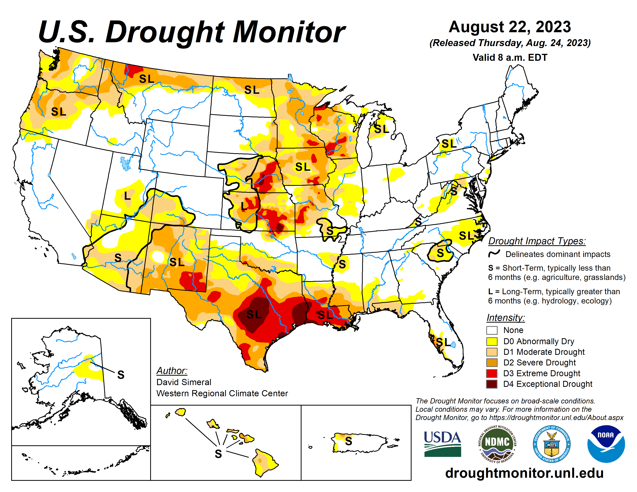

# REFERENCES

Egli, D.B., and P.L. Cornelius. 2009. A Regional Analysis of the Response of Soybean Yield to Planting Date. Agron. J. 101(2):330-335.

Federal Grain Inspection Service. 2004. Test Weight. *In* Grain Inspection Handbook II (Chapter 10). Washington DC: USDA-GIPSA-FGIS.

Helms, T.C., and J.H. Orf. 1998. Protein, oil, and yield of soybean lines selected for increased protein. Crop Sci. 38:707-711.

Medic, J., C. Atkinson, and C.R. Hurburgh Jr. 2014. Current knowledge in soybean composition. J. Am. Oil Chem. Soc. 91(3):363-384.

Mourtzinis, S., A.P. Gaspar, S.L. Naeve, and S.P. Conley. 2017. Agron. J. 109:2040-2049.

National Agricultural Statistics Service: NASS. 2023. Available at: <nass.usda.gov>

NOAA National Centers for Environmental Information, State of the Climate: National Climate Report, published online, retrieved October 29, 2023 from https://www.ncei.noaa.gov/access/monitoring/monthly-report/national/202309.

Pfarr, M.D., M.J. Kazula, J.E. Miller-Garvin, and S.L. Naeve. 2018. Amino acid balance is affected by protein concentration in soybean. Crop Sci. 58:1-13.

Ravindran, V., M.R. Abdollahi, and S.M. Bootwalla. 2014. Nutrient analysis, metabolizable energy, and digestible amino acids of soybean meals of different origins for broilers. Poultry Sci. 93:2567-2577.

Stein, H.H., L.L. Berger, J.K. Drackley, G.F. Fahey, Jr., D.C. Hernot, and C.M. Parsons. 2008. Nutritional properties and feeding values of soybeans and their coproducts. pp. 613-660 *In* Soybeans, Chemistry, Production, Processing, and Utilization. L.A. Johnson, P.J. White, and R. Galloway, eds. AOCS Press, Urbana, IL.

Thakur, M., and C.R. Hurburgh. 2007. Quality of US soybean meal compared to the quality of soybean meal from other origins. J. Am. Oil Chem. Soc. 84:835-

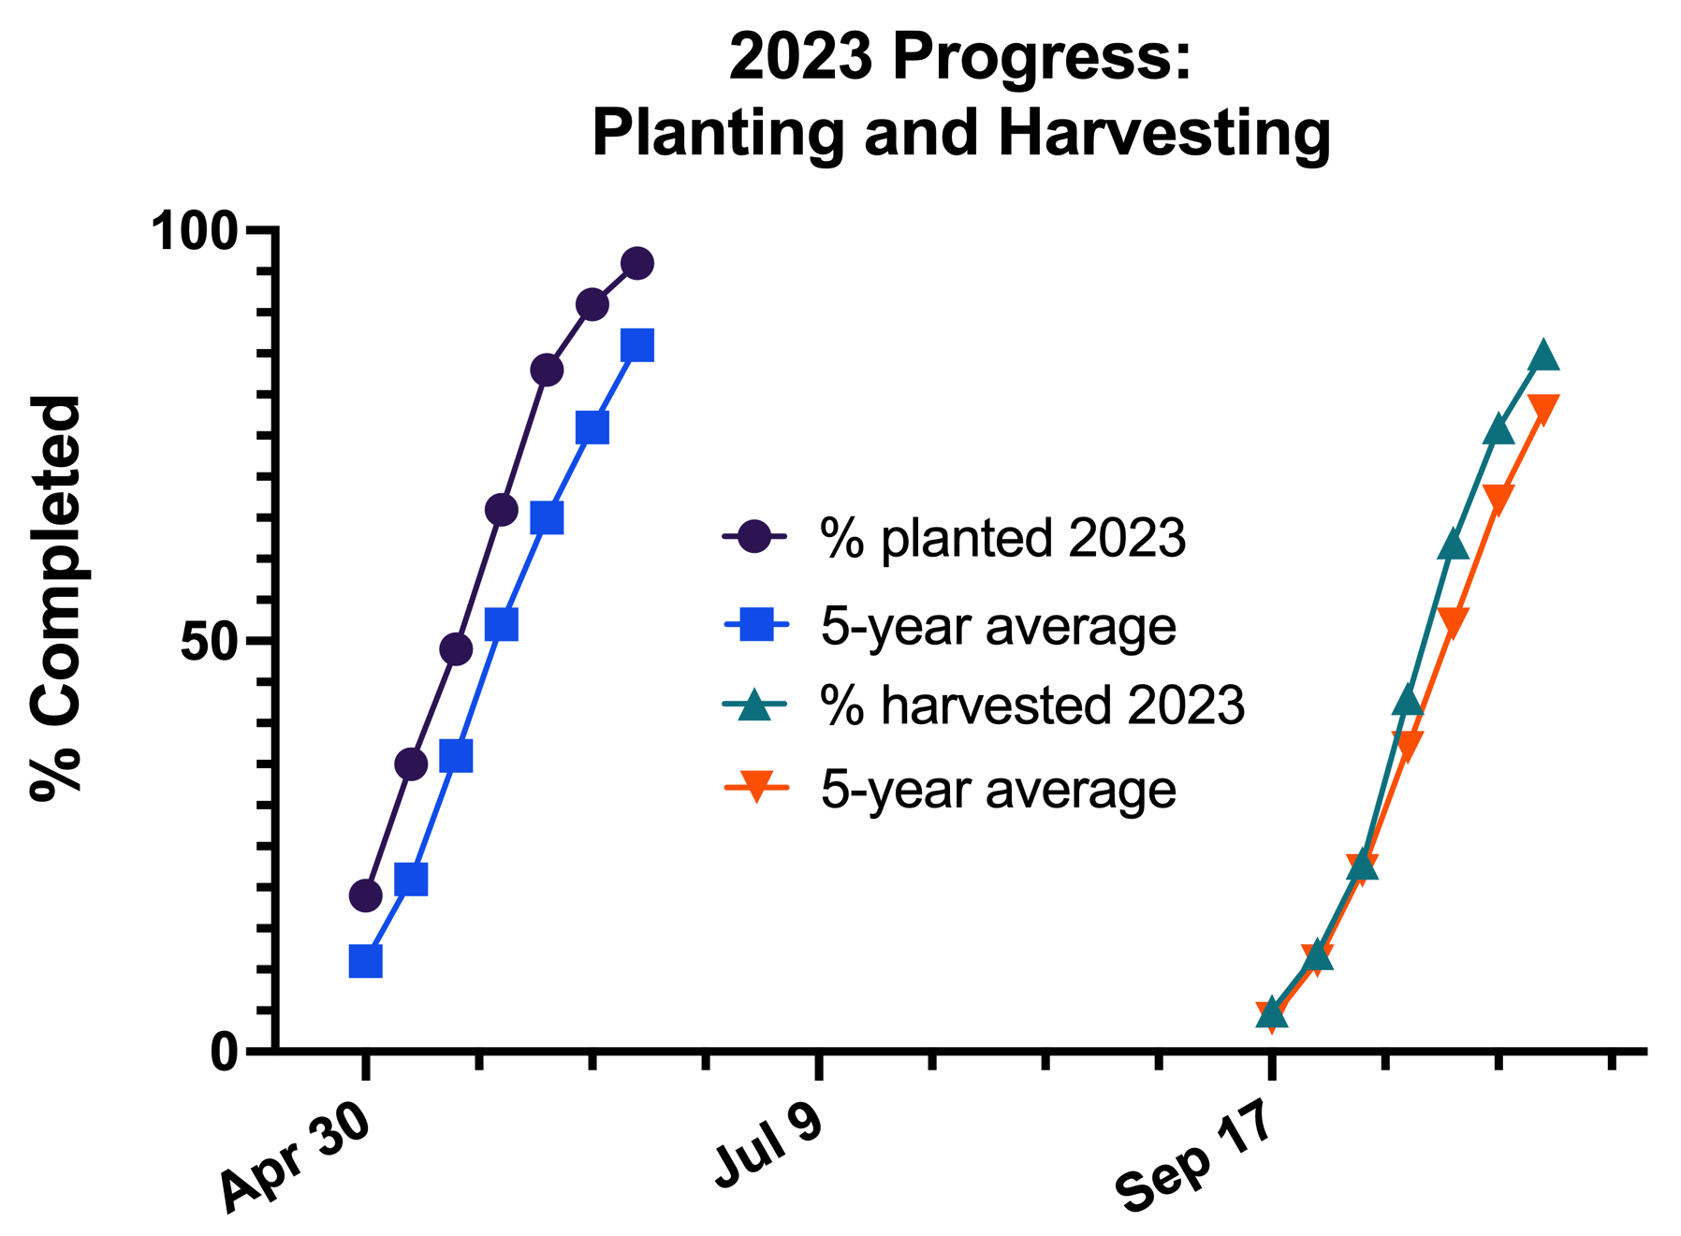Figure 1 Figure 1: US Soybean Planting and Harvest Progress -- Source: USDA NASS

Figure 2: US Soybean, Corn, Wheat Harvested Area -- Source: USDA NASS

Figure 3: US Protein and Oil State/Regional Summary

# Contact Information

|  |  |
| --- | --- |
| DR. SETH L. NAEVE  Professor of Agronomy |  |
| Naeve Headshot 2 |  |
| Naeve002@umn.edu | |

University of Minnesota  
Department of Agronomy & Plant Genetics  
411 Borlaug Hall  
1991 Upper Buford Circle  
St. Paul, MN 55108

**Tel** 612-625-4298

**Final updated reports will be available at**

**http:/z.umn.edu/soybean-quality**



*Funding provided by the United Soybean Board*